

The

**Happiest Minds Proposal Response to**

**ABB to Upgrade Angular Versions.**

ility



**Copyright Information**

This document is the exclusive property of Happiest Minds Technologies Pvt. Ltd. (“Happiest Minds”). The recipient agrees that they may not copy, transmit, use or disclose the confidential and proprietary information in this document by any means without the expressed and written consent of Happiest Minds. By accepting a copy, the recipient agrees to adhere to these conditions to the confidentiality of Happiest Minds practices and procedures.

**Confidentiality Clause**

This document is being submitted to ABB Group Ltd. (“ABB”) by Happiest Minds Technologies Pvt. Ltd. on the understanding that the contents of this document will not be divulged to any third party without the express written consent of the parties. It is also understood that the parties will not divulge any confidential information about ABB that it may have access to during this interaction.

**Disclaimer**

This document has been prepared based on the information provided by ABB. Wherever proposed, the solutions and/or services mentioned are based on the requirements defined and understood by us at the time of preparing this document. While every effort has been made to make this document as accurate as possible, there might be changes to the document based on the subsequent discussions.

Table of Contents

1 Executive Summary 4

2 About Happiest Minds 5

3 Requirement Details 6

Our understanding 6

In Scope 8

Out of Scope 10

Assumptions 10

Dependencies 10

4 Proposed Solution 11

System Architecture 11

5 Technical Execution approach 11

6 Engineering quality 12

7 Project Delivery Approach 16

Communication Management and Governance 17

Schedule & Deliverables 18

Acceptance Criteria 20

Change Request Management 21

8 Commercials 21

Cost for Development 21

Payment Schedule 22

Onsite Travel 22

Invoicing and Payment terms 22

Project specific costs and Expenses 23

Ownership 23

Terms and Conditions 23

# Executive Summary

# About Happiest Minds

Happiest Minds Technologies Limited (NSE: HAPPSTMNDS), a Mindful IT Company, enables digital transformation for enterprises and technology providers by delivering seamless customer experiences, business efficiency and actionable insights. We do this by leveraging a spectrum of disruptive technologies such as: artificial intelligence, blockchain, cloud, digital process automation, internet of things, robotics/drones, security, virtual/augmented reality, etc. Positioned as ‘Born Digital. Born Agile’, our capabilities span digital solutions, infrastructure, product engineering and security. We deliver these services across industry sectors such as automotive, BFSI, consumer packaged goods, e-commerce, Edutech, engineering R&D, hi-tech, manufacturing, retail and travel/transportation/hospitality.

A Great Place to Work-Certified™ company, Happiest Minds is headquartered in Bangalore, India with operations in the U.S., UK, Canada, Australia and Middle East.

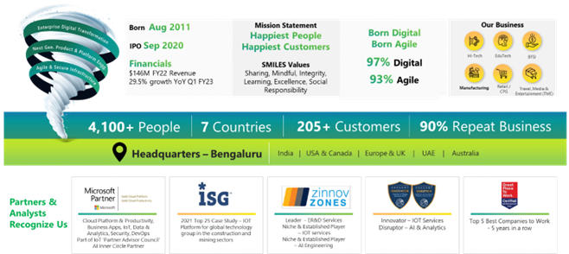

**Our Businesses**

# Requirement Details

## Our understanding

ABB has two instances of the Smart Master Application

1. Edge application which uses the configure the devices at edge and view analytics in the application.
2. Cloud application which shows the analytics of the devices

ABB is looking for upgradation of the existing Angular UI Framework for better compatibility, eliminating vulnerability issues if any and compliance with the ABB Enterprise standards.

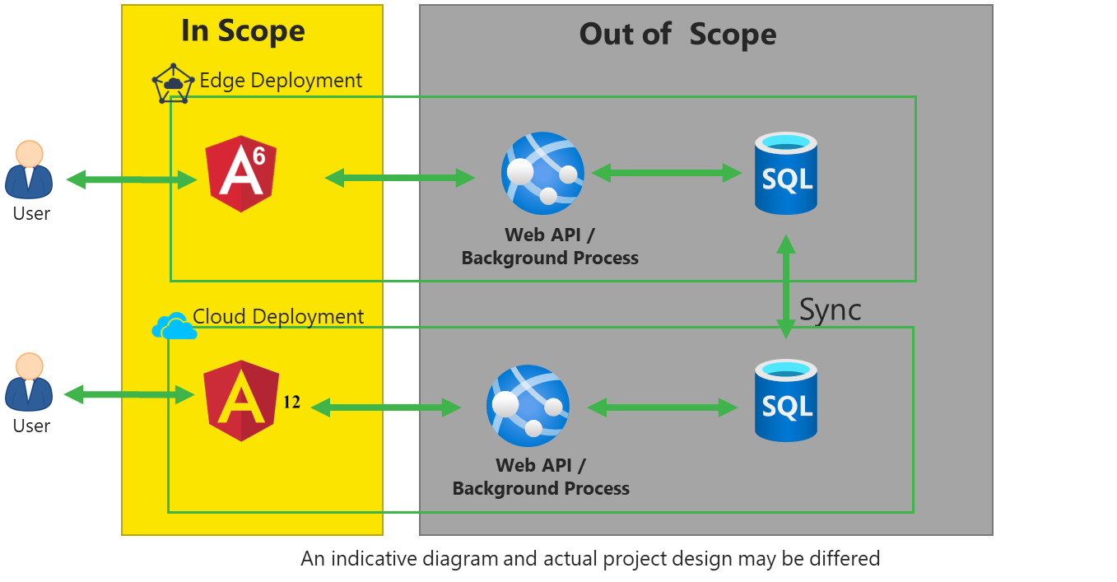

|  |  |  |
| --- | --- | --- |
| **Application** | **Existing Framework Versions** | **To Be Framework Versions** |
| Edge Application | * Angular 6 * Angular material UI 6.3 for Responsive Design * Infragistics Ignite UI 6.2.9 (Library for DataGrid and Chart Controls) | * Angular 12 * Angular material UI 16.0.1 * Infragistics 16.0 (Library for DataGrid and Chart Controls) |
| Cloud Application | * Angular 12 * Angular material UI 12.2.13 for Responsive Design * Infragistics Angular 12.2.0 (Library for DataGrid and Chart Controls) | * Angular 12 * Angular material UI 16.0.1 for Responsive Design * Infragistics Ultimate 16.0.1 (Library for DataGrid and Chart Controls) |

The following are the details of the scope considered for this proposal.

## In Scope

Below is the detailed scope identified against each of the applications, please note that the estimation and costing are done based on the below scope. Any changes to below scope either directly or during discovery phase will involve change in efforts and cost.

|  |  |
| --- | --- |
| Edge Applications | * Upgrade Angular from version 6 to version 15 for:   1. Ten (10) screens including basic configuration screens.   2. A simple one-dimensional Infragistics table with search functionality.   3. Two screens with Infragistics charts (line and trend). * Upgrade Angular Material UI version 6.3 to 16.0.1 * Infragistics ignite UI version.   igniteui-angular: ^6.2.9 to igniteui-angular:16.0  igniteui-angular-charts: ^7.2.0 to igniteui-angular:16.0  igniteui-angular-core": "^7.2.0 to igniteui-angular:16.0  igniteui-angular-gauges": "^7.2.0 to igniteui-angular:16.0 |
| Cloud Application | * Upgrade Angular from version 12 to version 15 for: * Fourteen (14) screens including basic configuration screens. * A simple one-dimensional Infragistics table with search functionality. * Two screens with Infragistics charts (line and trend). * Upgrade Angular Material UI V12.2.13 to 16.0.1 * Infragistics Ignite UI v12.2.0 to Infragistics Ignite UI 16.0 |

## Out of Scope

* Any Improvement to Backend and Angular Applications
* Modifications to the code in the Backend Application
* Substitution of third-party libraries
* Conducting Security and Penetration Tests
* Performance Testing
* Fixing functional bugs or functional changes
* Any Changes in the Integration or Data Synchronization

## Assumptions

* Happiest Minds will have access to both the applications and in-scope during the Discovery phase
* ABB adhered to industry best practices while developing the Angular Application.
* Documentation of Existing code, High-level design, low-level design, Architecture, Code walkthrough will be provided by ABB.
* ABB will provide access and coordination with third-party vendors.
* The existing Backend Application Web API are compatible with Angular 15
* ABB will provide test data and test case scenarios, at the beginning of Development phase
* Hardware, software & infrastructure procurement setup and support would be managed by ABB
* ABB to provide access to the existing test / defect management tool in the first week of Discovery phase.
* ABB will provide timely sign-off on test artefacts / deliverables.
* Any licensed software/ UI Library that arises during the execution of the project will be provided by ABB or Happiest Minds can purchase and bill it to ABB after mutual agreement.
* Response to Happiest Minds’ queries within two business days. Any considerable delays (delay more than 5 days) in response may impact effort, cost, and schedule and in these cases Happiest Minds shall discuss with ABB to invoke the change as per the Change Management mentioned in the section below.
* Happiest Minds team shall be performing the re-estimation to arrive at the final schedule & cost post the discovery phase.
* Upgraded applications will be compatible with Edge and Chrome versions 113 and above.
* The application will be tested on a single mobile device with a standard 6-inch screen.

## Dependencies

* Development and Testing environment required for development, upgradation and Testing activities shall be provided at the start of the project.
* Supported UI Library (Infragistics and Angular Material UI) to be shared by the customer at the start of the project.
* SME availability throughout the project.
* Test Strategy and Test scenarios should be reviewed and signed off by the client

# Technical Execution approach

|  |  |
| --- | --- |
| Step 1 - Discovery   * Gain a functional and technical understanding of the application. * Conduct a deep dive into the source code and complete a compatibility study by identifying deprecated methods, routing changes and Web pack changes. * Understand the Typescript standards and identify the changes required. * Understand the third-party libraries used and their compatible versions. | Deliverables   * Discovery Report with Feasibility Study * If required, Revised Approach, Timeline and price |
| Step 2 - Upgradation   * Use ng-Update to upgrade the versions of Angular, Angular Material UI, and Infragistics libraries. * Refactor the code to incorporate new features and remove deprecated methods. * Refactor the code to accommodate upgrades to third-party libraries. * Refactor the Unit Test cases if any. | Deliverables   * Upgraded Angular Application * Upgraded Unit Test Cases * Change Log Report in Happiest Minds Format |
| Step 3 - Validate, Test & Refine   * Conduct unit testing on all web pages and fix any issues arising from the upgrade. * Perform end-to-end testing on each application and fix any bugs. * Address any incompatibility issues arising by the upgrade. * Resolve any vulnerability issues arising by the upgrade. | Deliverables   * Test case documents for system testing, System integration testing, UAT * Test data for testing scripts * UAT Execution & Test Data * UAT Sign off |

# Engineering quality [Need to Update by Testing Team]

**Test Approach:**

The proposed migration testing for upgrading the GUI screens from Angular version 6 to 15 and Angular version 12 to 15 is detailed below. This provides details on various testing that would be covered as part of this assignment.

### Functional Validation

One round of functional validation will be conducted to ensure there are no regression. We would be considering the existing application as reference application to perform the functionality validation.

### UI Validation:

All the screens of the application would be validated for alignment, rendering and screen load time. There should not be any deviations from the existing application to the migrated application (except for any stated enhancements or changes considered).

### Compatibility testing:

Application would be validated on windows & 2 browsers (latest version) of IE and Chrome which are widely used in ABB. We would also be considering different layout validation (mobile web in portrait and landscape mode).

### E2E Testing

This Testing focuses on the E2E use cases that will be prepared by Happiest Minds and will be reviewed and agreed by ABB Stakeholders.

The focus is at an overall solution level such as Create a user, Register the devices, Authenticate the user, check message processing, and then check the payment flow.

It should be done through XIOT Platform with newly developed components by Happiest Minds team.

### User Acceptance Testing

UAT test cases would be prepared by customer stakeholders and happiestminds team would support during the UAT phase. Any defects identified during UAT phase would be discussed with ABB stake holders. All the agreed defects would be fixed and revalidated by happiest minds team.

UAT testing will be done by the customers in Production environment as there are device dependencies.

# Project Delivery Approach [Need to Refine by Delivery Team]

Agile Scrum framework would be used for project execution. Scrum ensures transparency in communication and creates an environment of continuous progress. The below diagram depicts the model followed by Happiest Minds in Agile projects.

2-week sprint cadence would be followed and there would be a demo at the end of each sprint.

## Communication Management and Governance

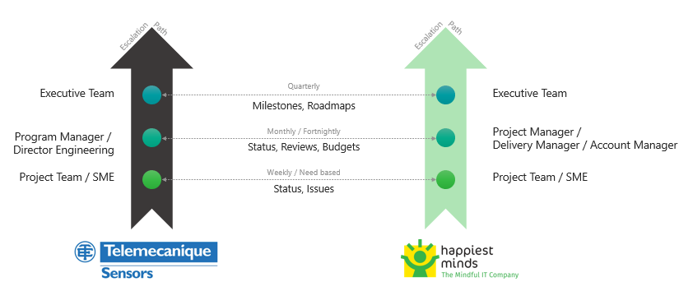

|  |  |  |  |  |
| --- | --- | --- | --- | --- |
| Communication Area/Topic | Communication Activity Area(s) | Audience | Timeline/Frequency | Owner |
| Executive | * Quarterly QBR * Monthly Meeting * Bi-weekly Meeting | Project Executive team | Quarterly / Monthly/ Frequency as discussed and agreed | Delivery Manager & Engineering Manager |
| Internal stakeholders’ outreach & communications | * Functional Req Meeting * Story grooming | Product Management & teams | Weekly/Bi-weekly | Engineering Manager / Product Owner/BA/Teams |
| Standard Project Reporting & communications | * DSM * Sprint/Iteration planning & Retro * WSP * Meeting Notes & AI * Project Schedule / Milestone progress meetings | Project teams; Stakeholders | Weekly-ongoing communications activities | Engineering Manager, Tech teams |

## Schedule & Deliverables

The delivery schedule is based on our current understanding of requirements. Any significant changes in scope of the project are expected to have an impact on the cost and schedule of the project.

It is recommended to execute the project by considering milestone-wise execution. This would help in timely identification of issues and covering of the gaps within project schedules.

Please note that these are indicative milestones and deliverables, and a detailed plan with milestones will be shared as a part of the Release plan at the start of the project.

## Change Request Management

Changes to the scope will mean any of the following:

* Any changes to the scope of the project as detailed in section “In Scope”
* Invalidation of any of the assumptions detailed in section “Assumptions”
* Any change to the terms and conditions as defined in Commercials and Payment Terms sections
* Non-fulfillment of any of the dependencies detailed in the sections Dependencies

In case of change request, the scheduled end date for this Project and/or the fees associated may change. Whenever a change is identified, it will be managed as per the below process:

* For any changes to the scope, either ABB Happiest Minds will submit a Change Request
* Happiest Minds will issue a Change Order providing the impact of the change to the schedule and/or fees
* ABB SPOC will review and either approve or cancel the change order.
* Changes will be implemented only after ABB SPOC approval and signing of the change order form by the Parties.
* For any ABB dependencies that are not met or issues that are not resolved, which could impact the schedule – Happiest Minds Project Manager will complete a Change Order and inform the ABB POC.

# **Commercials**

## Cost for Development

|  |  |  |
| --- | --- | --- |
| **Phase** | **Cost** | **Remarks** |
|  |  |  |
|  |  |  |

## Payment Schedule

Happiest Minds will invoice Sterling starting on Project start date (M0) and will follow the payment schedule set below:

|  |  |  |
| --- | --- | --- |
| **Milestone** | **Indicate Date (Month)** | **Amount** |
| Discovery and Assessment | TBC (T + 3 weeks) | EUR 20,000.00 |

*T = Project Start Date*

**Payment Terms:** Happiest Minds invoices will be raised at the end of each month and will be due for payment 30 days from date of invoice.

**Billing:** The monthly billing is computed on the basis of 183.75 hours per month irrespective of the number of working days in the month. Two leaves per person are allowed excluding Public holidays without any change to monthly charges. Any additional hours spent more than 10% of the allocated hours per month, will be tracked and reported to XXX. Billing for such hours will be prorated based on the services fees detailed above.

## Onsite Travel

Any fees related to travel, boarding/lodging required for the project will be over and above the services fees detailed in the above section. Any requirement for travel, with a duration not exceeding 6 calendar weeks, will be categorized as short-term and a coach class roundtrip airfare shall be charged on actuals and as per ABB travel policy (airfare, accommodation, allowances, and local conveyance). Any requirement for short-term travel will be discussed and mutually agreed between both parties.

## Invoicing and Payment terms

Invoices will be raised at the end of each milestone, and it will be due for payment by following the MSA guidelines.

## Project specific costs and Expenses

Happiest Minds will provide standard PC hardware loaded with Windows Operating System, MSDN Professional Subscription to its team members at its site for execution of work under this proposal. Any project specific specialized hardware, software licenses or networking infrastructure needed for the project will either be provided by ABB or will be procured and expensed to ABB. Happiest Minds will obtain prior written approval from ABB before procuring or incurring any project specific hardware, software or network infrastructure expenditure. For the avoidance of doubt, Happiest Minds shall not, and does not have any authority to, enter any contract or agreement on behalf of ABB.

## Ownership

The source code and binaries built for this project would be owned by ABB. Happiest Minds would either use ABB source control system or Happiest Minds system during the project execution. If Happiest Minds source control system is used, the latest source code would be packaged and transferred to ABB on mutually agreed interval.

## Terms and Conditions

**Taxes:** All rates exclude VAT and other local and country specific taxes including any withholding tax, as may be applicable